**Report “Lab 6”**

**Anton Tserakhau**

# Analytic Functions - Basic

## Task 01: Create Ad Hoc SQL FIRST_VALUE, LAST_VALUE

I have created ad hoc SQL, which will analyze measurement using Analytic Functions FIRST_VALUE, LAST_VALUE.

Select cities with minimum and maximum sales for each country in January 2012, add the field with category (minimum or maximum sales), sort by country in alphabetical order.

SELECT country_name AS country

, city_name AS city

, TO_CHAR ( amount

, '9,999,999' )

AS amount

, CASE

WHEN total_price = max_val THEN 'City with max value'

WHEN total_price = min_val THEN 'City with min value'

END

city_category

, TO_CHAR ( total_price

, '$999,999,999,999' )

AS total_price

FROM (SELECT t.*

, FIRST_VALUE ( total_price ) OVER (PARTITION BY country_name) AS max_val

, LAST_VALUE ( total_price ) OVER (PARTITION BY country_name) AS min_val

FROM ( SELECT countries.region_desc AS country_name

, cities.city_desc AS city_name

, SUM ( oper.unit_amount ) AS amount

, SUM ( oper.total_price_dol ) AS total_price

FROM t_operations oper

LEFT JOIN t_restaurants rest

ON oper.restaurant_id = rest.restaurant_id

LEFT JOIN t_restaurant_types

ON rest.restaurant_type_id = t_restaurant_types.restaurant_type_id

LEFT JOIN t_dishes dishes

ON dishes.dish_id = oper.dish_id

LEFT JOIN t_dish_types

ON dishes.dish_type_id = t_dish_types.dish_type_id

LEFT JOIN t_dish_cuisines

ON dishes.dish_cuisine_id = t_dish_cuisines.dish_cuisine_id

LEFT JOIN u_dw_references.lc_cities cities

ON rest.restaurant_geo_id = cities.geo_id

LEFT JOIN u_dw_references.t_geo_object_links links

ON links.child_geo_id = cities.geo_id

LEFT JOIN u_dw_references.cu_countries countries

ON links.parent_geo_id = countries.geo_id

WHERE TRUNC ( oper.event_dt

, 'MONTH' ) = TO_DATE ( '01-JAN-2012'

, 'DD-MON-YYYY' )

GROUP BY countries.region_desc

, cities.city_desc

ORDER BY countries.region_desc

, total_price DESC) t)

WHERE total_price = max_val

OR total_price = min_val;

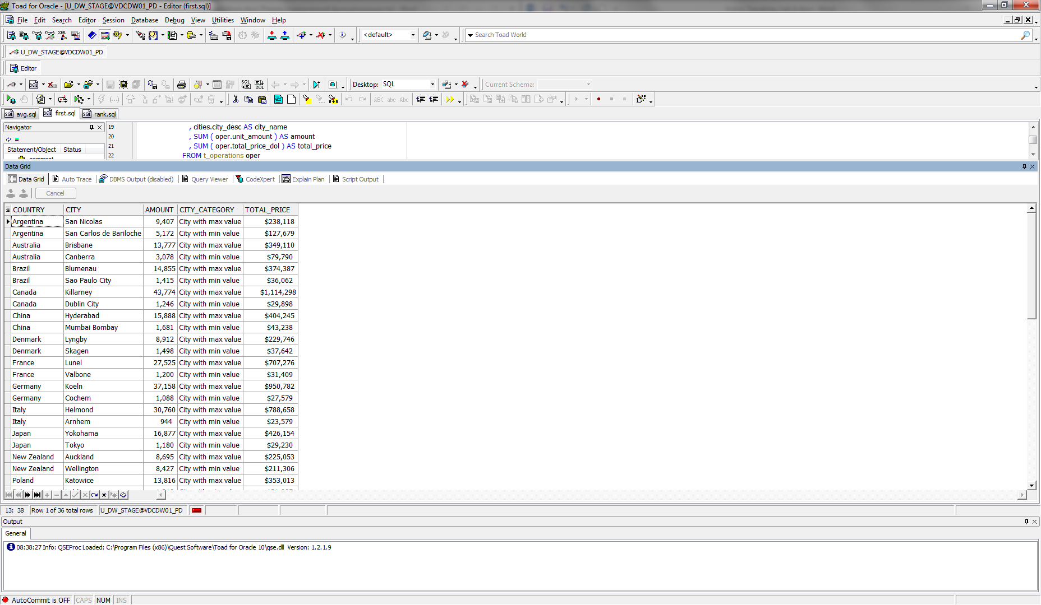

## Task 02: Create Ad Hoc SQL RANK, DENSE_RANK, ROWNUM

I have created ad hoc SQL, which will analyze measurement using Analytic Functions RANK, DENSE_RANK, ROWNUM.

Select TOP-3 cities with the highest sales by country in January 2012, add the fields indicating the ranking of sales by country and sales ranking over the world, sort by country in alphabetical order.

SELECT *

FROM (SELECT country_name AS country

, city_name AS city

, DENSE_RANK ( ) OVER (PARTITION BY country_name ORDER BY total_price DESC) AS rating_sales_in_country

, RANK ( ) OVER (ORDER BY total_price DESC) AS rating_sales_in_world

, TO_CHAR ( amount

, '9,999,999' )

AS amount

, TO_CHAR ( total_price

, '$999,999,999,999' )

AS total_price

FROM ( SELECT countries.region_desc AS country_name

, cities.city_desc AS city_name

, SUM ( oper.unit_amount ) AS amount

, SUM ( oper.total_price_dol ) AS total_price

FROM t_operations oper

LEFT JOIN t_restaurants rest

ON oper.restaurant_id = rest.restaurant_id

LEFT JOIN t_restaurant_types

ON rest.restaurant_type_id = t_restaurant_types.restaurant_type_id

LEFT JOIN t_dishes dishes

ON dishes.dish_id = oper.dish_id

LEFT JOIN t_dish_types

ON dishes.dish_type_id = t_dish_types.dish_type_id

LEFT JOIN t_dish_cuisines

ON dishes.dish_cuisine_id = t_dish_cuisines.dish_cuisine_id

LEFT JOIN u_dw_references.lc_cities cities

ON rest.restaurant_geo_id = cities.geo_id

LEFT JOIN u_dw_references.t_geo_object_links links

ON links.child_geo_id = cities.geo_id

LEFT JOIN u_dw_references.cu_countries countries

ON links.parent_geo_id = countries.geo_id

WHERE TRUNC ( oper.event_dt

, 'MONTH' ) = TO_DATE ( '01-JAN-2012'

, 'DD-MON-YYYY' )

GROUP BY countries.region_desc

, cities.city_desc

ORDER BY countries.region_desc

, cities.city_desc))

WHERE rating_sales_in_country <= 3;

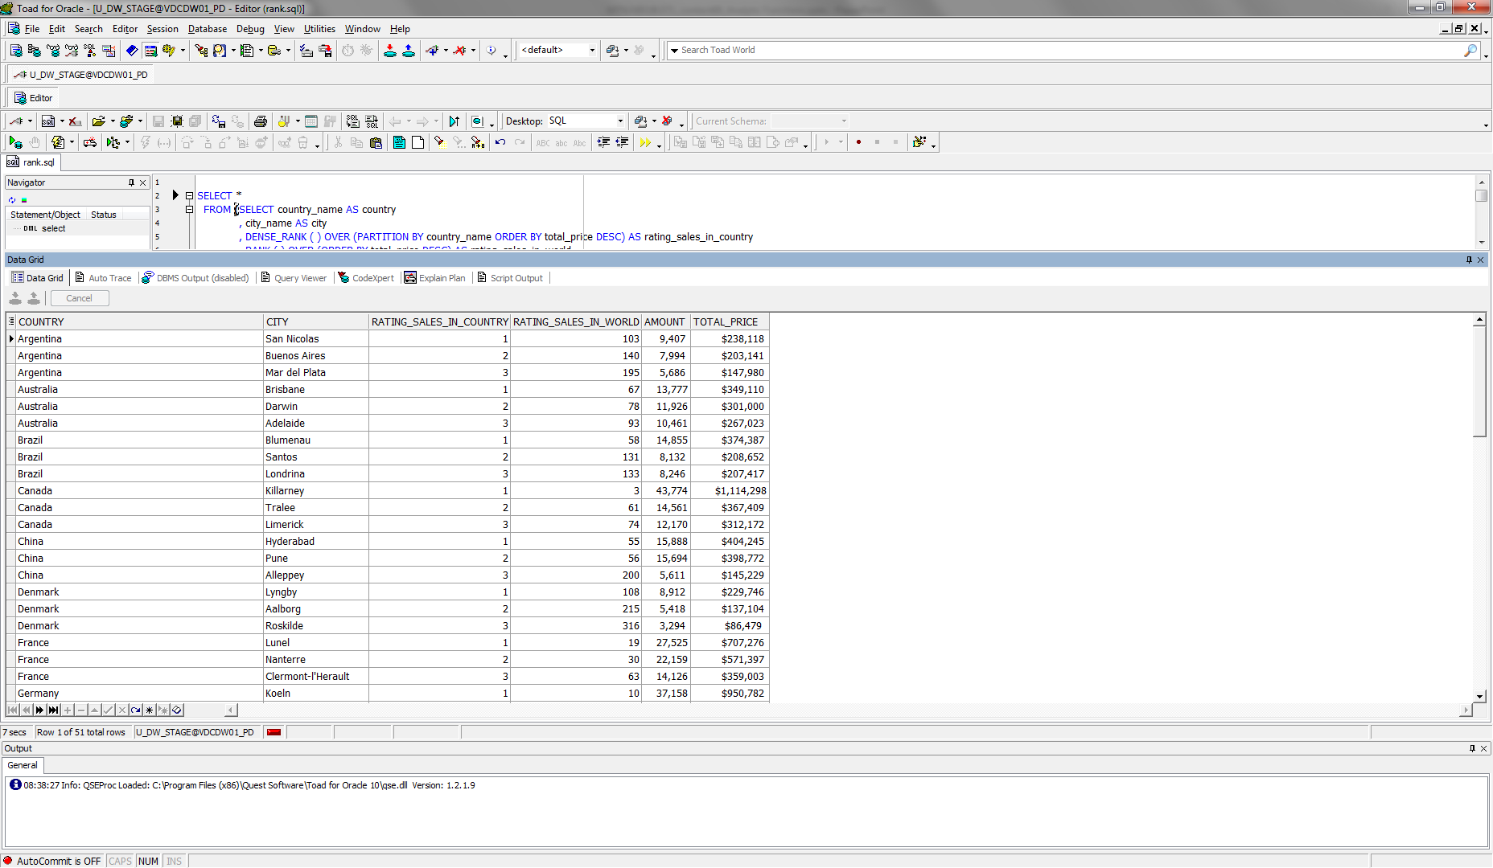

## Task 03: Create Ad Hoc SQL AGGREAGATE FUNCS

I have created ad hoc SQL, which will analyze measurement using Analytic Functions AGGREAGATE FUNCS (MAX, MIN, AVG).

Select cities with sales for each country in January 2012, add the fields showing minimum / average / maximum sales by country, sort by country in alphabetical order.

SELECT country_name AS country

, city_name AS city

, TO_CHAR ( amount

, '9,999,999' )

AS amount

, TO_CHAR ( min_sales

, '$999,999,999,999' )

AS min_sales

, TO_CHAR ( avg_sales

, '$999,999,999,999' )

AS avg_sales

, TO_CHAR ( max_sales

, '$999,999,999,999' )

AS max_sales

, TO_CHAR ( total_price

, '$999,999,999,999' )

AS total_price

FROM ( SELECT DECODE ( GROUPING ( countries.region_desc ), 1, 'All Countries', countries.region_desc ) AS country_name

, DECODE ( GROUPING ( cities.city_desc ), 1, 'All Cities', cities.city_desc ) AS city_name

, SUM ( oper.unit_amount ) AS amount

, MIN ( SUM ( oper.total_price_dol ) ) OVER (PARTITION BY countries.region_desc) AS min_sales

, AVG ( SUM ( oper.total_price_dol ) ) OVER (PARTITION BY countries.region_desc) AS avg_sales

, MAX ( SUM ( oper.total_price_dol ) ) OVER (PARTITION BY countries.region_desc) AS max_sales

, SUM ( oper.total_price_dol ) AS total_price

FROM t_operations oper

LEFT JOIN t_restaurants rest

ON oper.restaurant_id = rest.restaurant_id

LEFT JOIN t_restaurant_types

ON rest.restaurant_type_id = t_restaurant_types.restaurant_type_id

LEFT JOIN t_dishes dishes

ON dishes.dish_id = oper.dish_id

LEFT JOIN t_dish_types

ON dishes.dish_type_id = t_dish_types.dish_type_id

LEFT JOIN t_dish_cuisines

ON dishes.dish_cuisine_id = t_dish_cuisines.dish_cuisine_id

LEFT JOIN u_dw_references.lc_cities cities

ON rest.restaurant_geo_id = cities.geo_id

LEFT JOIN u_dw_references.t_geo_object_links links

ON links.child_geo_id = cities.geo_id

LEFT JOIN u_dw_references.cu_countries countries

ON links.parent_geo_id = countries.geo_id

WHERE TRUNC ( oper.event_dt

, 'MONTH' ) = TO_DATE ( '01-JAN-2012'

, 'DD-MON-YYYY' )

GROUP BY ROLLUP ( countries.region_desc, cities.city_desc )

ORDER BY countries.region_desc

, cities.city_desc);

